**CheckMate User Guide**  
  
**Tip**: Logging In  
**Tip**: Adding , searching and deleting records  
**Tip**: Managers, Reps and receipts  
**Tip**: Deployment  
**Tip**: Report(s)

**Tip**: Logging In  
From the login screen  
  
Enter in your email address and password.  
  
If you don’t have on, select “signup” to create an account  
  
  
Once logged in, The main menu will appear  
  


**Tip**: Adding , searching and deleting records

Each screen has the same functionality in terms of adding. Updating and deleting record.  
  
To add a record, select “add …..”  
  
When in add mode, you will notice that the “Update Record” button is “disabled”  
  
The submit button, adds a new record, You get a success message when the record is added.  
  
  
The Add New Button, clears the screen for you to add another record (but by default, when you add a new record, the screen clears automatically),  
  
**SEARCHING FOR A RECORD**  
To search for a record:  
  
Each search screen has it’s own set of criteria, in the example below, I selected “**all**” from the Enter Search Criteria dropdown:  
  
To Delete record, hit the trashcan  
  
To view a record, hit the binoculars

  
  
As you can see above, the update record button  
  
Is now “enabled” for “update” the existing record. The **Submit and Add new buttons are “disabled”**  
  
**Tip**: Managers, Reps and receipts **Managers, Reps and Receipts**  
  
On these three screens, there relationships:  
**A Rep Record “has” to have a manager, a Receipt record “has” to have a rep.**  
  
So first we add a Manager:  
Go to Search to see a list of managers in your system:  
  
When we add a Rep record there is a “dropdown” with the list of managers shown above.  
Below is the dropdown:  
  
The same goes for when entering a receipt:  
  
  
**Tip**: Report(s)

Reports can be accessed:

And also as shown below, you can export the results to .csv file

**Tip**: Deployment  
There are two ways of viewing the application  
**Step One:**  
There will be a link to a hosted site on Heroku (**Shared later**)  
  
**Step Two:**  
**Docker** Local container install  
<https://docs.docker.com/desktop/install/mac-install/>  
  
  
Docker allows you run the application as an image installed locally on your computer.  
When docker is setup and installed and the container is created, you will see the container for it when you start docker up.  
  
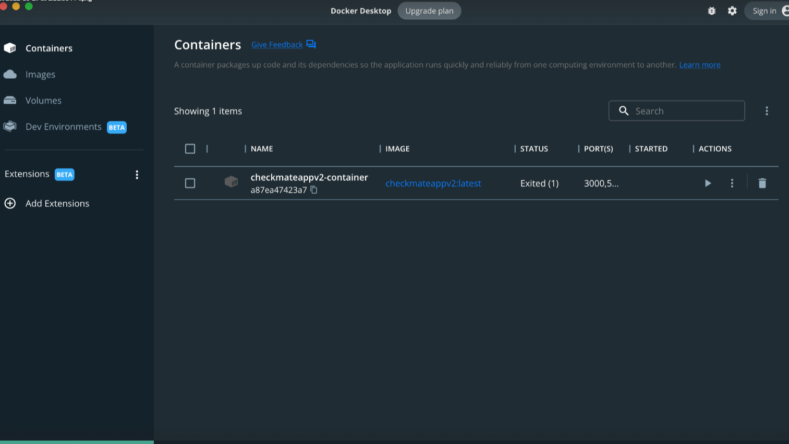  
  
You hit the run icon  
  
When it is running, you will see the status – started  
  
Then you can go to your browser and type:  
<http://localhost:3000>  
